A Message from our Co-Presidents

Maureen Slocum and Mary Anne Strohmaier

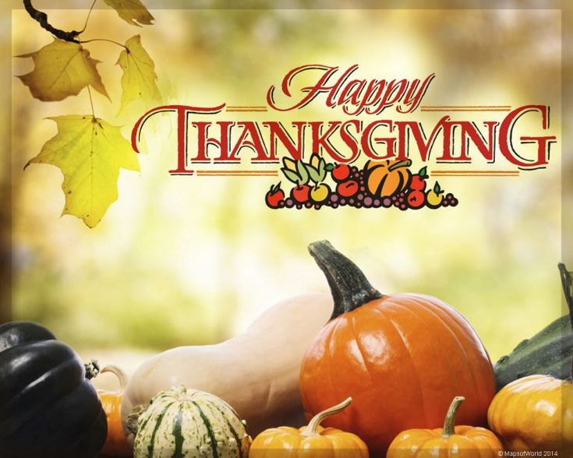

"As autumn settles in and we prepare for Thanksgiving, let's take a moment to appreciate the beauty and bounty our gardens have given us. Each bloom, leaf, and harvest reminds us of the joy and wonder that nature brings. Thank you to each of you for sharing your love of gardening and for the warmth you bring to our club. Wishing you a season filled with gratitude and the simple joys of the garden."

**November birth month flowers – Chrysanthemum and Peony**

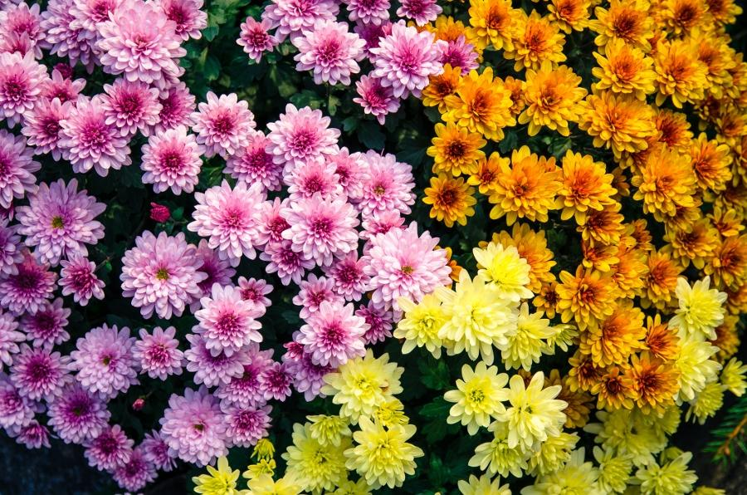

Chrysanthemums are often associated with longevity and joy, representing a life filled with happiness and abundance.

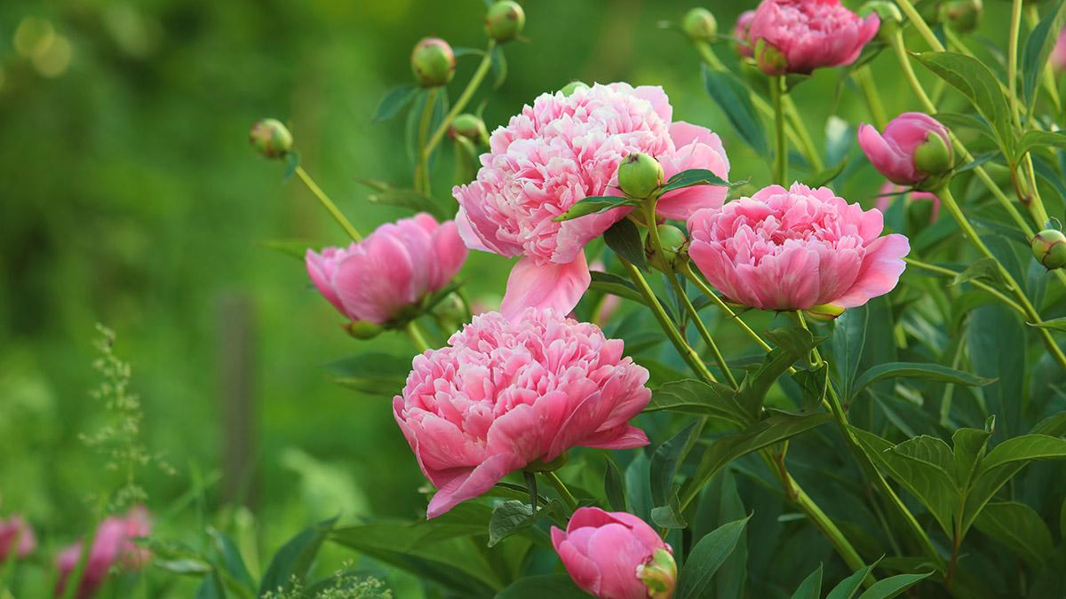

People often associate peonies with romance, love, and good fortune. In some cultures, these flowers represent compassion and even healing.

**Please remember to bring your water bottle to our** **meeting.**

Volume 17, Issue 3

November, 2024

# Thursday, November 14

10a – social  
10:30a – meeting begins  
Gil Albiani Recreation Center  
8830 Sharkey Ave.

# November Speaker

Tora Rocha, with the Oakland based Pollinator Posse.

# Inside This Issue

Page 1 – President’s message

Page 1 – Refreshment committee

Page 2 – Nov. meeting

Page 2 – November Birthdays

Page 2 – April Plant Sale

Page 2 – Did You Know?

Page 3 – Garden Corner

Page 3 - Pumpkin Succulent class

Page 3 – MG Calendars

Page 4 – Nov. Garden Checklist

Page 4 – Calendar of Events

Page 4 – SRVD Meetings

# Refreshment Committee

**November** -Pat Pereira and Jane Evans – Team Leaders; Linda Brett, Jennie Hertzler, Mary Lee Trimmer, Ines Wright, Chris Duane, Patti Jong

**December** –Mary Anne Strohmaier, Team Leader; Nancy Baldwin, Kathy Krikorian, Margrethe Reed, Sharon Saint Denise Robertson, Vivian Sellers, Ana Weekley

# November Meeting

Our November speaker, Tora Rocha, is a team member with the Oakland based Pollinator Posse. The Pollinator Posse develops and encourages pollinator-friendly landscaping and fosters appreciation for local ecosystems through outreach, education, community science and habitat creation. With eco-friendly landscape techniques at the heart of our work, we teach respect for the creatures which keep the world blooming.

# November Birthdays

Pat Baeta 11/07

Mary Tolan-Davi 11/11

Marilyn Peterson 11/18

Patti Jong 11/23

Kate Genato 11/28

Jane Evans 11/28

Mary Adams-Wiley 11/29

**###**

# April Plant Sale

It’s not too late to start cuttings and/or divisions of perennials for our plant sale. Remember to make a label for your plant(s)

EGGC will provide labels for our plant sale so that all plants will be labelled the same and have all the information needed. A sample will be included with each packet of labels.

In addition, if you need potting soil or pots, contact Vivian Sellers.

At our February meeting, we will start seeds of flowers and vegetables for the sale. We will need empty, washed pony-packs. Please start saving now.

**###**

# Did You Know?

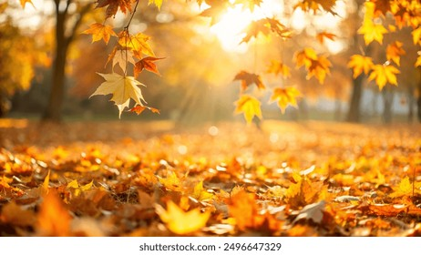

**Leaves are actually fall colors, not green**

[Fall](https://www.deseret.com/utah/2024/10/04/photo-gallery-spectacular-fall-colors/) is such a beautiful time of the year. It’s that season of change in the air. Despite popular belief, when the leaves change, they’re returning to their original color, not changing into something else.

So that means the red, yellow and brown hues are the leaves’ natural colors, rather than green.

**Why do leaves change color in the fall?**

While leaves are growing, there are three types of pigments produced in the leaves that influence autumn colors; Chlorophyll, Anthocyanin and Carotenoids.

Chlorophyll is a key ingredient in producing energy from light and is the reason leaves are green. While leaves are growing, chlorophyll is constantly “produced and broken down,” and that’s why leaves appear green to us, according to [the U.S. Forest Service](https://www.fs.usda.gov/visit/fall-colors/science-of-fall-colors).

“As night length increases in the autumn, chlorophyll production slows down and then stops and eventually all the chlorophyll is destroyed,” per [the Forest Service.](https://www.fs.usda.gov/visit/fall-colors/science-of-fall-colors) “The carotenoids and anthocyanin that are present in the leaf are then unmasked and show their colors.”

The species of deciduous trees that produce stellar fall colors are Maple, Aspen, Birch, Oak and Gum.

From an article by [Sarah Gambles](https://www.deseret.com/authors/sarah-gambles/) & Jeffrey D. Allred in the Deseret News

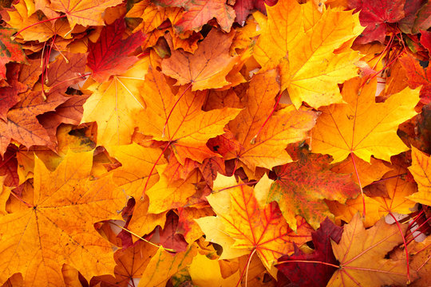

“Autumn is a second spring when every leaf is a flower.” – Albert Camus

**###**

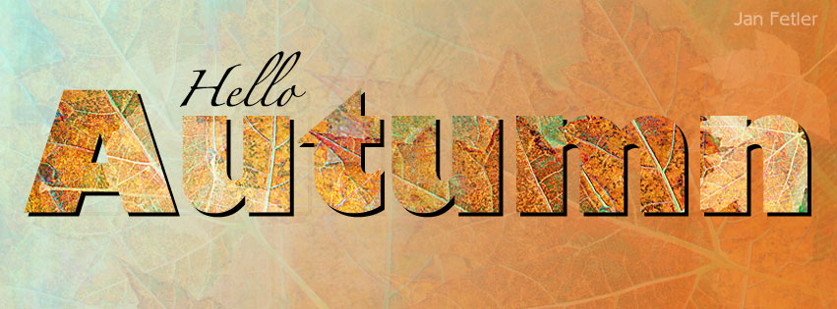

# Garden Corner

# By: DeAna Melilli, Landscape Committee

Autumn marks a time of togetherness with friends and family. What a great time for a storybook stroll in the garden and to make some wonderful pumpkin decorations and enjoy some pumpkin spice and pie. There are two types of pumpkins; one to eat and one used for decorations.

### Best Pumpkin to Eat

Finding the best pumpkin to eat can be tricky as the term “Pumpkin” is considered a catch-all term for “winter squash”. For example, butternut squash is a buff-colored Dickinson Pumpkin, commonly found in canned pumpkin. The best pumpkins to eat are considered any hard-skinned squash. When choosing a pumpkin for eating, look for one that is heavy for its size, with a hard rind, and intact skin free of bruises, cuts, or dents.

*(Butternut, Hubbard, Acorn, Kabocha, Ked Kuri, Spaghetti, Delicata, Buttercup, Etc.)*

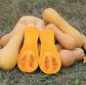

### Best Pumpkin for Decoration

Pumpkins used for food differ from those used for decoration or carving. Decorative pumpkins are typically grown to be either very large or very small, mostly hollow, and with flat bottoms. The flesh is typically watery and bland.

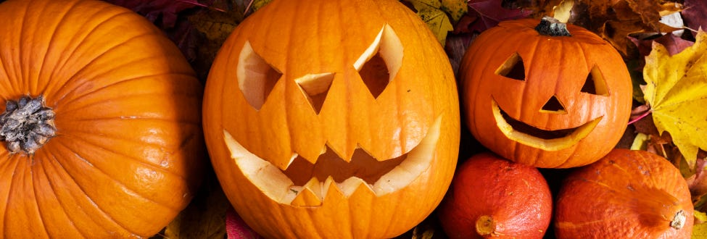

#### Having Fun with Beautiful Succulent Pumpkins

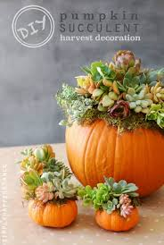Succulents can survive in a pumpkin for 2 to 3 months. Perfect for the fall season. Let’s look at how to care for your succulents over winter.

The key to winter proofing succulents is in protecting them from frost by reducing watering and ensuring they get enough light. A warm blanket of mulch, rock, or straw around the base helps with installation.

All gardens are a blessing. Your garden is your personal fairytale that you can share with neighbors or keep as your own secret garden.

To all the amazing gardeners I hope your holidays are full of wonder and happiness as you get to spend time with your friends,

**###**

# ****Pumpkin Succulent Class****

Thanks to all of you for helping make this year’s class a success, Vivian

**###**

Master Gardener Calendars

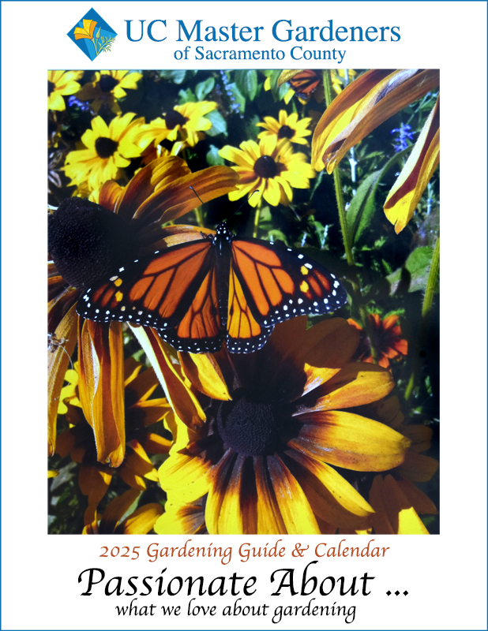

Our 2025 Gardening Guide and Calendar is here, is still $12 and I‘ll have a supply of them for your purchasing pleasure at our November 14 meeting. Each month you'll get loads of advice along with science based tips providing gardening insight and inspiration to the Sacramento region since 2004. What are we passionate about in the garden? To name a few: succulents, shade gardens, herbs, wildflower meadows, ornamental grasses, container gardening and inviting kids to be passionate about gardening too. Happy days ahead in your garden,

Vivian

**###**

November Garden Checklist ~~~

By Jan Fetler

*Drain water from the irrigation system before turning if off to prevent ice form damaging it.

*Plant vegetable seeds: bok choi, lettuce, spinach, radishes, peas, etc.

*Plant seedlings of bok choi, kale, lettuce and peas.

*Fertilize October planted vegetables

*Plan frost protection for citrus, tender perennials, succulents and tropical plants. Use when temperatures drop below freezing.

*Apply copper spray on peaches and nectarines to reduce peach leaf curl. Apply towards the end of the month when the leaves have fallen and again in December.

*Let hips form on roses to encourage dormancy.

*Clean tools before they are stored for the winter. Sharpen pruners for the winter pruning season.

*Save fallen leaves to add to the compost pile when there are fewer “browns” available next spring and summer.

*Clean up plant waste, fallen fruit and dead fruit remaining on trees to reduce disease and insects next year.

**###**

# Calendar Upcoming Events

**November 16** (Saturday) 9a till 1p

**UC Davis Arboretum Plant Sale** (Clearance)   
<https://campusmap.ucdavis.edu/?b=204>

**Nov. 16/17** (Saturday/Sunday) 1 till 4p/10a till 2p

**Chrysanthemum Show and Sale**  
Shepard Garden & Arts Center  
3330 McKinley Blvd., Sacramento

# Sacramento River Valley District Meetings

Clipboard will be passed around at meeting for those who are interested in attending SRVD meetings. The next meetings:

**February 11, 2025** (Tuesday) 8:30a till 1:30p

Speaker – McKenzie Wieser, CEO Sacramento Splash

**May 12** (Tuesday) 8:30a till 1:30p

Speaker – Judy Eitzen, Rosarian and Master Gardener

**###**



# Elk Grove Garden Club Leaders

Co-Presidents – Maureen Slocum and Mary Anne Strohmaier

Vice-President – Ana Weekley

Secretary – Mary Lou Lange

Treasurer – Susan Muckey

<https://www.elkgrovegardenclub.org/>

**Elk Grove Garden Club is a member of:**

Sacramento River Valley District  
California Garden Clubs, Inc.   
Pacific Region of National Garden Clubs, Inc.   
National Garden Clubs Inc.

***The Newsletter Team***

Editor – Vivian Sellers, [janfetler@gmail.com](mailto:janfetler@gmail.com)

# This Month’s Contributors

Maureen Slocum, Mary Anne Strohmaier and DeAna Melilli